**API Implementation Process**

Firstly I added an event listener to ensure all page content loads before Javascript runs and retrieves elements from the HTML file (get-dog-fact & dog-fact).

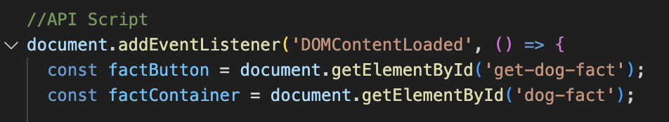

I then added a click event listener which will run the function inside the event when the button is clicked.

Screenshot 2025-02-15 at 23.43.23.png

The below code was then added. It fetches the data from the API. If the response from the server is unsuccessful, an error message will display “Failed to fetch dog facts.”

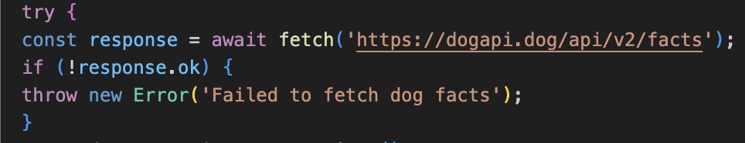

The below code then converts the API response from raw text to an object in Javascript. data.data[0] gets the first fact from the response. ?. (optional chaining) ensures no errors if properties are missing.

.attributes.body extracts the actual fact text. If the API returns no fact, this sets a default message “No fact found!”.

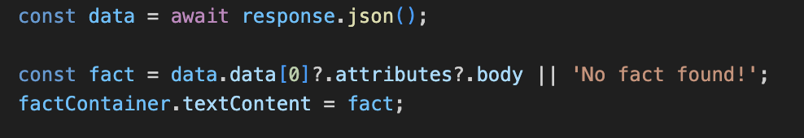

The final piece of code logs an occurring error to the console and then displays an error message in the UI.

